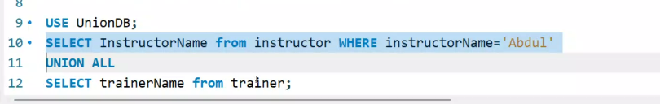



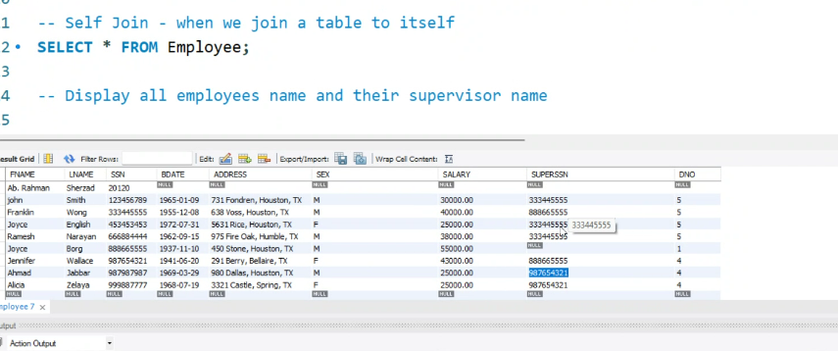



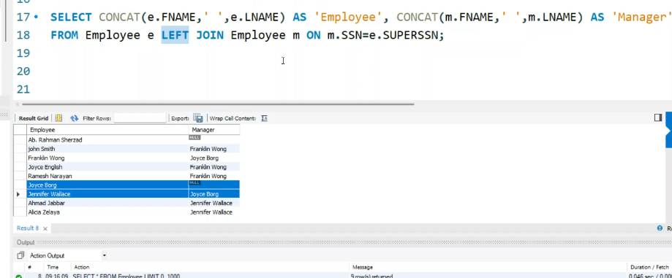

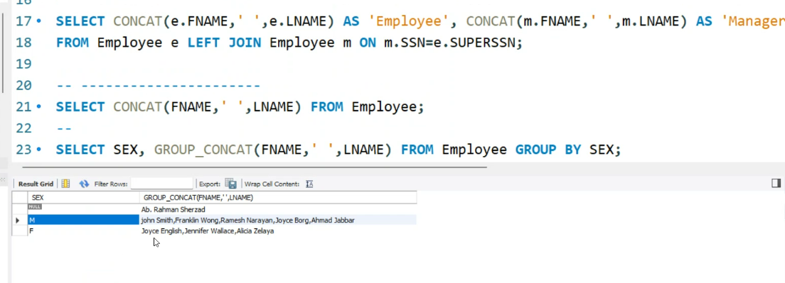

**NOW()/CURRENT_TIMESTAMP()**

**CURDATE()/CURRENT_DATE()**

**CURTIME()/CURRENT_TIME()**

**MONTHNAME()   DAYNAME()**

**DAY()**

**YEAR()**

select dayname('1959-07-06'); // returns Monday

-- What is Inner Join - Tanzina  
-- What is Left Join -- Luqman  
-- What is Right Join -- Robert  
  -- All the data from the Right table is selected and only the common data from the first  
-- What difference between Union and Join -- Fatinah  
  --

-- CROSS Join -- work similar to inner join  
SELECT * FROM Instructor CROSS JOIN Trainer ON trainerName=InstructorName;

-- Self Join - when we join a table to itself   
SELECT * FROM Employee;

-- Display all employees name and their supervisor name  
-- you need to use mysql ALIAS for table

SELECT CONCAT(e.FNAME,' ',e.LNAME) AS 'Employee', CONCAT(m.FNAME,' ',m.LNAME) AS 'Manager'  
FROM Employee e LEFT JOIN Employee m ON m.SSN=e.SUPERSSN;

-- ----------------------  
SELECT CONCAT(FNAME,' ',LNAME) FROM Employee;  
--   
SELECT SEX, GROUP_CONCAT(' ',FNAME,' ',LNAME) FROM Employee WHERE SEX IS NOT NULL GROUP BY SEX;

-- TRIM()  
SELECT TRIM('       ZAK            ') AS Name;  
SELECT RTRIM('                          ZAK            ') AS Name;  
select FNAME, LNAME from employee;

SELECT UPPER(FNAME), UCASE(TRIM(LNAME)) FROM Employee;  
SELECT CURRENT_USER();  
/*  
NOW()/CURRENT_TIMESTAMP()  
CURDATE()/CURRENT_DATE()  
CURTIME()/CURRENT_TIME()  
MONTHNAME()  
DAYNAME()  
DAY()  
YEAR()  
*/  
SELECT NOW();  
SELECT CURDATE();  
SELECT CURRENT_TIME();  
SELECT MONTHNAME(CURDATE());  
SELECT DAYNAME(CURDATE());  
SELECT DAYNAME('2024-01-28');  
-- Birth day name  
SELECT DAY(CURDATE());  
SELECT YEAR(CURDATE());  
SELECT YEAR('2022-01-28');

SELECT DATE_FORMAT(CURDATE(), "%m %d %Y");  
SELECT DATE_FORMAT(CURTIME(), "%S");

SELECT FORMAT(250500.5654, 2);   
SELECT FNAME, LNAME, TRUNCATE(SALARY,0) AS 'Salary' FROM Employee;

SELECT TRUNCATE(250500.5654, 2);

30 of January 2024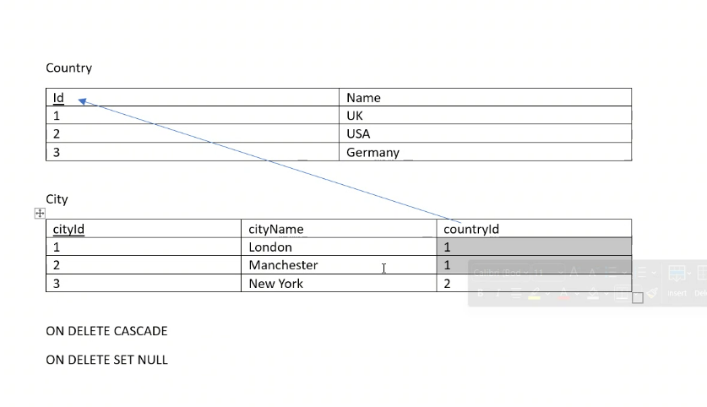

CREATE DATABASE Day_7;  
USE Day_7;  
CREATE TABLE Country  
  (  
    id INT PRIMARY KEY,  
    name VARCHAR(20)  
    );  
CREATE TABLE City  
  (  
    cityId INT PRIMARY KEY AUTO_INCREMENT,  
        cityName VARCHAR(20),  
        countryId INT,  
        FOREIGN KEY (countryId) REFERENCES Country(id) ON DELETE SET NULL  
  );  
INSERT INTO Country VALUES(1,'UK'),(2,'USA'),(3,'Germany');  
INSERT INTO City(cityName, countryId) VALUES  
  ('London',1),('Manchester',1),('New York',2);  
select * from city;  
select * from country;  
DELETE FROM Country WHERE Name='UK';

show warnings;

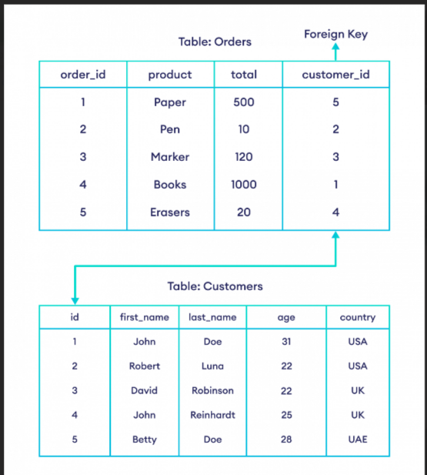

I would also like you to search on Insert ignore in MySQL.

<https://sqlbolt.com/>

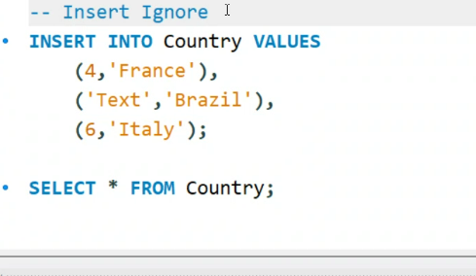

If ‘Text’ is changed to ‘7’ then MySql will automatically convert it to a number

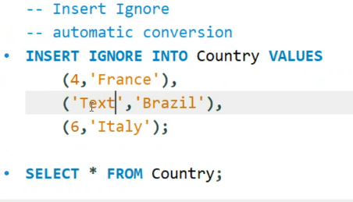

SET SQL_SAFE_UPDATES=0; // to overcome Foreign Key Constraints

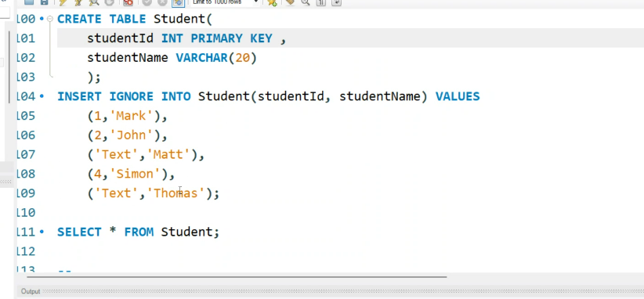

The first ‘Text’ record will be inserted automatically with primary key = 0.



The zero disables permanent commits.

Command ROLLBACK; will recover lost data but command COMMIT; will not allow the rollback to function.

Cannot rollback truncated data. DROP and TRUNCATE commands automatically commit the data change.

Tomorrow we will cover STORE procedure. We will also look at MongoDb so try to download it.

